Table of Contents

1. INTRODUCTION 2
1.1. Voltage Transformer 2
1.2. Problem Definition 2
1.3. Transformer Data 2
2. STATE of ART 3
2.1. Partial Discharges 3
2.1.1 Testing of partial discharges 6
2.2. Insulating Materials used in Mv voltage transformers 7
2.2.1 Epoxy Resin 8
2.2.2 Insulating Paper 11
2.2.3 Insulating Gases 12
2.3. Manufacturing Process 13
2.4. Factors that effect the electrical field distribution 13
2.4.1 Modification of the screen , 13
2.4.2 Effect of the Er in the field distribution 14
3. COIL LAYER DESIGN & MODELING of MV VOLTAGE TRANSFORMERS 20

INTRODUCTION

Voltage Transformer

Problem Definition

Transformer Data
1.2.2 loss rates
1.4 Methodology

1.4.1 Finite Element Analysis

STATE of ART

The aim of this section is to provide a better understanding of the manufacturing technology and material used in Mv Voltage transformers. To accomplish this goal the literature on the insulating materials and production process will inspected.
The partial discharges can be originate from design errors where the field intensity under the operation exceeds the withstand of the insulating medium..
Partial discharges
Adjustments tweaks ,
tweaks will be applied/
In order to evaluate the partial discharge problem
Insulating material , especially, plays a vital role in determining the

Partial Discharges
It is clear from the table XX that the main problem in the gt30a is the partial discharge levels being above the above value of the standard. A better knowledge of partial discharges is required to address this particular problem.
According to IEC 60270 partial discharge (PD) defined as a localized electrical discharge that only partially bridges the insulation between conductors and which may or may not occur adjacent to a conductor. Electrical breakdowns, that causes partial discharges, happens when the electrical field stress exceeds the breakdown stress of the insulation material at any point of the design.
When the regional breakdown occurs the electric field rapidly changes and creates a current flow. This current should be large enough to be detected by the measurement equipment and must be repetitive enough to be distinguished from a random noise only after that it will be recognized as the partial discharge. [1]
As in the case of GT30a ,a product may pass the voltage withstand tests such as 1 min power frequency and standard lightning impulse test and still have undesired partial discharges. The reason of this is partial discharges usually do not cause immediate breakdown of the insulating medium but slowly deteriorates it. If a device with partial discharge detected sent to field it can fail at a random instance at near or far future.
Partial discharges are caused by;
- Breakdown in a cavity inside the dielectric
- Breakdown in a tree inside the dielectric (Figure 2-1)
- Breakdown in interfaces between different dielectrics
- Breakdown in a foreign substance inside the dielectric
- Breakdown around a floating conductor inside the dielectric
The partial discharges, once incepted, in time either bridge the gap between insulating medium or create conducting paths that short circuits the electrodes.
Corona discharge is also a form of partial discharge where the medium is fully composed of dielectric gas. Similar to the Pd when the field stress in a gas exceeds the breakdown strength , the gas ionizes and acts like a conductor but fails to bridge between the electrodes. Corona discharges occurring at gas insulated coil of the voltage transformer are dangerous since the energy created might damage the insulating paper and create a conductive surface. Test standard do not distinguish between corona or partial discharge , meaning that maximum electric field of the voltage transformer coil should be below the corona inception voltage of the gas utilized under the test conditions.
Figure 2-1 A branch type electrical tree growing through transparent resin insulation from a fine point electrode[2]
Partial discharges are not only dependant of the dielectric strength of the material but also the sizes of the cavities in them. As can seen from Figure 2-2. where an EPR cable with different void diameters tested , partial discharges are proportional to the cavity volume in the solid insulation . Vitality of the cavities in the solid insulation are also dependant on the positioning. Small voids caused by the production errors may be tolerated if they are not situated at the high stress points of the transformer.

Figure 2-2 PD magnitude as a function of spherical cavity size for 15 kV, EPR cable geometry assuming that the cavity discharges at the peak of a 2.5 pu excitation (30 kV).[3]

Testing of partial discharges
A transformer in the field can be exposed to short term over voltages and is expected to operate safely after the surge pass. An overvoltage could form a electrical tree and trigger partial discharge and it may continue even after the voltage returns to the rated value. To simulate such conditions partial discharge test is applied after the power frequency test which is usually 1.5-3 pu of the rated voltage. A partial discharge is allowed to occur at the peak voltage but it should extinguish when the voltage is reduced to partial discharge test level .
Expected lifetime of the transformer reduces exponentially with the partial discharge and even with best equipment available it is hard to detect any signal below the 2 pC level. Therefore to ensure some safety regarding the lifetime of the transformer the partial discharge test voltage itself is above the rated voltage.
Pd detection system;
The partial discharge equipment used in the transformer testing of the GT30a have the following properties;
Maximum Test Voltage: 100 kV AC
Noise level : 3pC
labdan resim al.

Remarks; To ensure the successful passing from the partial discharge test each time of the insulating mediums in the gas insulated mv voltage transformer should not exceed their respective breakdown strength limits during the test. A suitable safety margin should also be adopted to reduce failures due to the non idealities such as void cavities in the mediums.

Insulating Materials used in Mv voltage transformers
In high voltage insulation applications there are various insulation materials in all gas, liquid and solid forms. The main parameter of the insulation material is dielectric strength which also varies with the applied voltage being AC, DC or impulse. The other determining parameters of the material choice are the application conditions such as working temperature , type of the casing , humidity ..etc and the cost.
The literature on the major insulating materials are settled over the past decades where major changes have been made . Introduction of the Sf6 gas led to development of gas insulated switchgears , advancement of the polymer technology changed the materials used in the power cables and transmission line insulators and resin technology allowed the construction of dry type power transformers.[4]
Urbanization trend shows that due to the increased wages in the major cities both city population and density increases[5]. This leads to a dense energy consumption and increase the cost of the space. Therefore the power equipment , especially at the distribution level, should also be able to provide dense energy in smaller space.
Fitting the systems with the same power rating to a smaller possible area is the goal of the high voltage design. Optimizing the geometry of the high voltage devices would help to achieve this goal which will be practiced at chapter 3 . The optimization process would be limited at the strength of the insulating materials. The properties of some of the most common material that are currently utilized are given in the Table 2-1.
Material | Spesific gravity (g/ml) | Relative dielectric constant | Dielectric loss tangent (x 10⁻⁴) | Volume resistivity (Ώcm)
SF6 | 6.1*10⁻³ | 1.0 | --- | ---
Insulating oil (mineral oil) | 0.88 | 2.2 | 10 | 7.6*10¹⁵
Kraft paper (oil immersed) | 0.7-0.8 | 3.5 | 38-39 | 2.3-2.4*10¹⁵
Pressboard (oil immersed) | 0.95-1.30 | 4.4 | 50 | 10¹⁶
Epoxy resin (alumina-filled) | 2.3-2.5 | 5.9-6.2 | 20-50 | 10¹⁶
Epoxy resin (silica filled) | 1.7-1.8 | 3.8-4.6 | 30-200 | 10¹⁶
Feldspar porcelain | 2.3-2.5 | 5.0-6.5 | 170-250 | 10¹³ - 10¹⁴
XLPE | 0.93 | 2.2-2.6 | 2-10 | >10¹⁶
Mica | 2.7-3.1 | 6-8 | 50 | 10¹⁴ - 10¹⁵
Table 2-1Basic physical properties of major insulating materials[6]
Gas insulated voltage transformers are constructed with three different insulation material which are epoxy resin (solid) , Sf6 (gas) , insulating paper (solid). Epoxy resin is used to construct the outer envelope of the transformer while the paper provides mechanical support and insulation in between layers of magnet wire. Lastly a pressurized Sf6 fills in the gaps in the coil and increases the overall electrical strength of the coil.
Since there is more than one type of insulation included the distribution of the electrical field will be effected by the difference of the relative dielectric constants and the design should be done with accordance.

Epoxy Resin
Epoxy resin is a mixture consisting of filler (silica , alumina or similar materials) , hardener , resin , accelerator and depending on the application flexibilizer. Epoxy resins are widely used in the both low voltage and high voltage applications. In this application the epoxy resin casing of the transformer both provides electrical insulation and mechanical support.
As a solid insulation, epoxy resin have unpredictable breakdown behavior under AC voltage . The breakdowns are caused mostly by partial discharge .Starting point and the magnitude of the discharge effects the breakdown characteristics. The breakdown time and breakdown voltage both varies in a large range because of the randomness of the partial discharge location[6]. The interpretation of this is the field strength should not critically approach the specified breakdown value of the resin.
Epoxy resin casting is a three step production:
- Preparation of the resin mixture
- Casting
- Post curing
The details of these steps are dependent on the type of the resin used , volume of the product and the casting type.
The mechanical and the electrical properties of the epoxy resin mixture varies with the mixture receipt and resin preparing process. The receipt that is used in the manufacturing of the GT30a is given at the Table 2-2 .
Mixture | Used | Recommended
Resin | 100 pbw | 100 pbw
Hardener | 85 pbw | 85 pbw
Flexibilizer | 20 pbw | 0-20 pbw
Accelerator | 0.8 pbw | 0.5-1.5 pbw
Filler (Silica) | 385 pbw | 345-385 pbw
Table 2-2 Epoxy resin mixture receipt
When creating the receipt electrical breakdown strength should be prioritized over the mechanical properties of the epoxy resin mixture since the limitations in this application is more electrical than mechanical and there is no force applied on the resin under normal operating conditions.
Flexibilizer should be added at the maximum allowed amount since it reduces the internal mechanical stresses in the epoxy resin . The transformer is susceptible to the thermal shock when first released from the mould and flexibilizer reduces the chance of a micro crack formation. On the other hand adding flexibilizer reduces the glass transition temperature (tg) of the resin but this effect is ignored due to the low power nature of the mv voltage transformers.
The electrical properties of the mixture given at the Table 2-2 is as following ;
Electrical Properties | Test Standard | Value | Unit
Breakdown Strength | IEC 243-1 | 20-24 | kV/mm
HV Arc Resistance | ASTM D 485 | 185-190 | s
Tracking Resistance solution A | IEC112 | >600-0.0 | CTI
Tracking Resistance solution B | IEC112 | >600M-0.0 | CTI
Loss Factor (50°C) | IEC250 | 42796 | %
Dielectric Constant (50°C) | IEC250 | 4 | E
Volume Resistivity (50°C) | IEC93 | 10¹⁵ | Ω*cm
Table 2-3Electrical properties of the epoxy resin mixture
Resin mixture behavior is dependent on the preparation process . To achieve the properties given at the Table 2-3 in each production batch ,the process must be controlled . The temperature, humidity of the facility must be stable. There should also be no air current in present to prevent the thermal shock . To avoid the mistakes caused by the human factor , the resin should be prepared in a fully automatic enclosed system .
Epoxy resin Casting methods;
- Conventional Casting : The resin is filled the mould under vacuum . Have long casting and post curing time. Moulds are cheap but multiple moulds are required for the serial production.

- APG : The resin s filled the mould under pressure. Have short casting and curing time. Final quality is dependent on the ability of the mould to extract the air in the filling process. Moulds are expensive and gets damaged over the time fast due to the pressure.

- Conventional Casting Under Sf6 : The resin is filled the mould under SF6. Have similar characteristics with the conventional casting. The cavities inside the resin is filled with Sf6 instead of air therefore gaining robustness.
In GT30a the conventional vacuum casting method is utilized. Casting duration is 4 hours and the post cure duration is 12 hours. The electrical strength of the resin will be taken as 20 kV/mm for the analysis . The dielectric constant of the resin is tested with sheering bridge by using 6mm resin plate since it may vary with the mixture and the process.

Insulating Paper
Cellulose based insulation papers are mostly used in junction with the mineral oils to provide electrical insulation in the power transformers[7]. The reason of the usage of the oil as a medium have 2 reasons. First the dielectric strength of the paper in air about 5 times lower than it is in mineral oil. Second the mineral oil also provides cooling for the coil. For the mv voltage transformers the mineral oil cannot be utilized in junction with paper because it hinders the adhesion between resin and the coil.
The load of GT30a is 10 VA indicating that there is no thermal constraints in the voltage transformer design. Insulating gas should be used for compensating the low dielectric strength of the paper. With the insulating gas filled in to the coil , purpose of the paper is reduces to providing mechanical support to the wires to hold them in space.
Properties of the insulation paper used in gt30a are given in the Table 2-4 ;
Properties | Standard | Value | Unit
Thickness | IEC60641-3-2 | 30± 10% | micron
Density | IEC60641-3-2 | 1.0-1.2 | g/cm³
Electrical Strength in air | IEC60641-3-2 | ≥8 | kV/mm
Dielectric Constant (50°C) | IEC60641-3-2 | 2.3 | E
Moisture Content | IEC60641-3-2 | ≤ 8%
Table 2-4 Electrical properties of the insulating paper in GT30a

The moisture content should be removed by thermal treatment before the epoxy resin casting. The thickness tolerance will affect the coil design , more precise the paper thickness is the smaller the safety margins could be selected in the coil design.

Insulating Gases
Insulating gasses are commonly utilized in the power applications such as gas insulated substations , gas insulated transmission lines , gas insulated transformers , gas insulates circuit breakers ..etc. A good insulation gas should have following properties[8];
- High dielectric strength (relative to air)
- High vapor pressure
- High thermal conductivity
- Chemically inertness
- Non-flammable, non toxic and non explosive
Sf6 is such man made gas and it has been commercially available since 1947. It is still widely used in the power system equipment manufacturing and it will be the choice of insulation gas in GT30a.
As an insulating gas Sf6 have almost constant breakdown voltage under same conditions although the time to breakdown may vary[6]. This allows construction of a precise design.
The Sf6 is injected in to the coil with 5 bar pressure . Although there is a routine leakage test (table...) , transformers mv voltage transformers may leak Sf6 over the years and drop to 1 bar pressure therefore the voltage transformer should be functional even with 1 bar pressure.
The corona inception voltage of the Sf6 gas with normal conditions under non-uniform e field is about 9.1 kV/mm [9] .
The corona extinction voltage is more critical than the inception voltage due the nature of the test which is argued in 2.1.1. The corona extinction voltage versus the corona inception voltage rates under AC voltage varies between %87-%80 ,with the different electrode setups that represents the possible errors in the gas insulated equipments[10].
Sf6 gas is a potent greenhouse gas. In the short term the amount of gas in the atmosphere is negligible but in the long run it would accumulate [11] . In the literature it is argued to replace Sf6 gas with possible alternatives . N2 gas with small amount of Sf6 mixtures is the current solution to reduce amount of the sf6 gas released in to the atmosphere.

table

The N2+Sf6 gas mixture could be adapted to the GT30a and the proportion of the mixture could be determined by the volume margin that will be gained from the optimization as the more N2 in the mixture lower the dielectric strength is. ()

Manufacturing Process

Factors that affect the electrical field distribution
Sf6 should be able to pass under 5 bar even if the design
The resin is the most....
production discipline

Usage of the screen
The

Effect of the Er in the field distribution
In gas insulated mv voltage transformers there are three different type of insulation material is used as discussed in section 2.2. Each of the materials has different relative dielectric constant and this will affect the electric field distribution. paper bul.
To evaluate the impact of the E_{r} on the electrical field distribution two examples with the same cylindrical electrode setup will be simulated. Electrode diameter is 40 mm ,spacing in between the two electrodes is selected as 6mm . Applied voltage is 1 kV. The analysis type is cylindrical around 2D Z axis.
Example 1: Material E_{r} is selected as 2 . The uniformly distributed electric field value is 0,166 kV/mm as can seen from the Figure 2-3
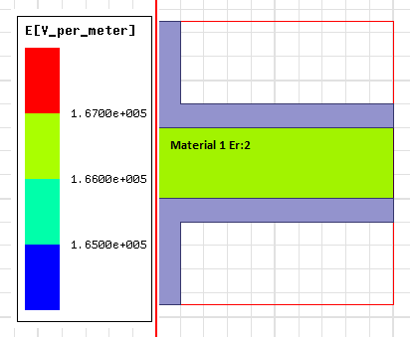
Figure 2-3 Electric field distribution in a medium with single type dielectric
Example 2: Material 1 on the top side has the E_{r} value 2 and at the material 2 bottom has the Er value 4.Sizes of the dielectrics are the same. In the simulation the electric field value of the material 1 is 0,22 kV/mm and material 2 is 0,11 kV/mm as can be seen from the Figure 2-4.
When the example 1 and example 2 is compared it is observed that the maximum electric field increases if there is more than one type of material in the medium. This increase would be more significant as the difference between the material dielectric constants increase. The material with low E_{r} will have more field drop on itself. This is basically a voltage distribution between the capacitances since every dielectric is a capacitor. paper bul.
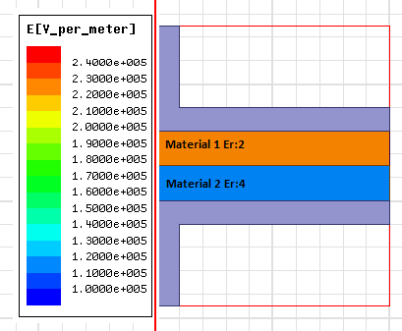
Figure 2-4 Electric field distribution in a medium with two different dielectric
Er values of the materials used in Gt30a and their respective dielectric strength is shown in the Table 2-4.
Material | Dielectric Constant | Dielectric Strength (kV/mm)
Sf6 (1 bar) | 1.002 | 9,1
Insulation paper | 2.3 | 8
Epoxy Resin | 4 | 20
Figure 2-5 Dielectric constants and strength of insulating materials used in GT30a
With the high dielectric constant , the presence of epoxy resin would increase the stress on the insulation paper and the Sf6 gas. Therefore minimal amount of epoxy resin should be used.
Winding of the GT30 is produced with three different type of layers with different length which will be discussed in Chapter 3&4. When there is transition from one type of the layer to the another the paper may be kept the same length (Figure 2-6) or cut with respect to the upcoming layer (Figure 2-7) .
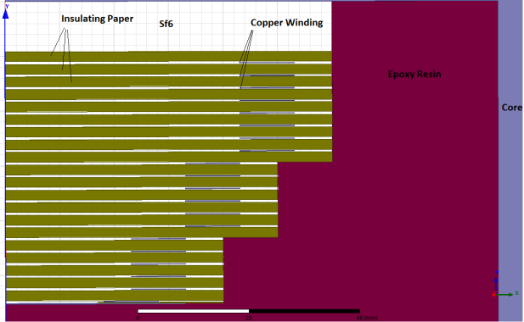
Figure 2-6 Slice of the transformer with stepped paper
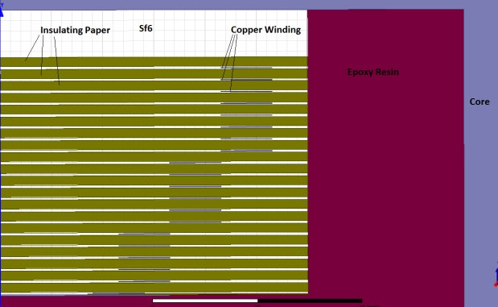
Figure 2-7 Slice of the transformer with constant paper length
The only advantage of the transformer with stepped paper orientation is the slight field stress reduction on the epoxy resin which can be compensated by increasing the screen diameter as discussed in the section 2.4.1. On the other hand when the straight paper is used the electrical stress in both in sf6 and insulating paper decreases , volume of the resume used decreases meaning lower cost and lower chance of uncured part occurring inside the resin.
Remarks ;
- Material with similar dielectric constants should be selected whenever is possible or the material with lower dielectric constant should have higher dielectric strength
- Geometry of materials with high dielectric constant should be arranged to not amplify the electric stress on the critical points in the design
2.4.3 Coil side covering
After the winding process is completed (Figure 2-8) the epoxy resin mixture is injected to envelope the coil . Although the resin itself has viscosity around 15000 mPa·s at the injection temperature there is a chance that epoxy resin may penetrate inside the coil.
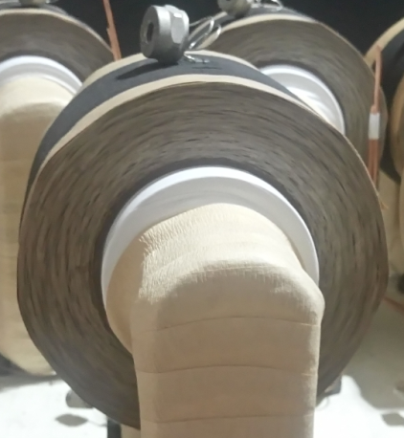
Figure 2-8 Side of the coil after the winding process
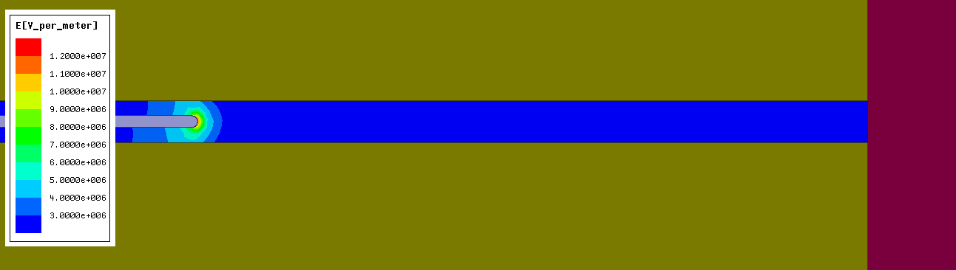
Figure 2-9 Coil without epoxy resin penetration
When the resin is present inside the coil there are two possible dangerous situation.
- The dielectric constant of the resin is higher than the Sf6 and the insulation paper so the filling of the coil with resin would amplify the field stress both in sf6 and the paper as discussed in section 2.4.2 (Figure 2-10)
- The resin may trap air and create a large cavity in the surface of the conducting wire and directly trigger the partial discharge as discussed in section 2.1 (Figure 2-11).
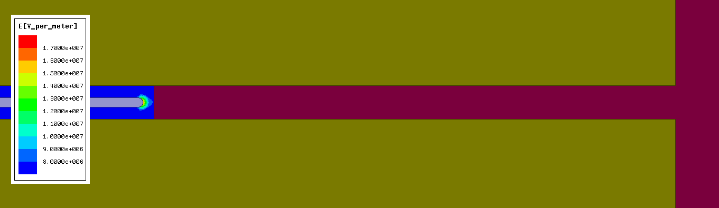
Figure 2-10 Coil with epoxy resin filled in between insulation papers
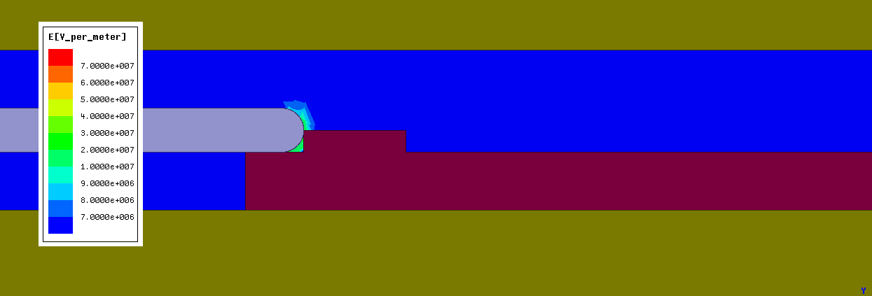
Figure 2-11 Coil with cavity caused by the epoxy resin on the conductor surface
When the results are inspected , it is found out that the field stress increased about %50 percent when there is resin presence in between the insulation paper and when there is a gap formed the maximum stress is 6 times more than what it should be . Both situations are increases the risk of partial discharge at the test voltage.
To prevent the entry of the resin in to the high voltage coil the coil sides should be covered before the resin injection process. The material that the side is covered must have high surface tracking resistance to prevent the surface flashover. The material should also be compatible with the resin used and should not cause any adhesion problems. Lastly the material should be able to withstand the temperatures at the curing and the post curing stages of the mv transformer without decomposing. Room temperature cured epoxy resin based AV106 (Table 2-5) manufactured by the huntsman have such characteristics.
Av 106 | Value | Unit
Cure Temparature / Duration | 20-150/15-0.1 | °C/hours
Dielectric constant | 3.4 | Er
Surface resistivity | 1.2*10¹⁶ | Ω
Volume resistivity | 10¹⁵ | Ω*cm
Table 2-5 Properties of Av106
A thin layer of Av106 should be applied to the side surfaces and cured before the epoxy resin injection (). This would prevent the intake of the resin to the coil and all the coils would have the expected field distribution shown in the Figure 2-9 . Similar materials can be used for this application. Physical strength of the material used also should be checked if the APG is used instead of the vacuum since the pressured resin may tear the material used.

2.4 .4 Modifications results

a Screen size increased from 0.1 to 0.2 mm ,and slightly shifted
- Sides are covered with av106
- Papers kept at full length
Results:
2.5Chapter Summary
In this chapter general knowledge about the partial discharges have been..

COIL LAYER DESIGN & MODELING of MV VOLTAGE TRANSFORMERS

The coil of a single phase voltage transformer is constructed on a rectangular core by winding the wire in the limited area (Fig. 3-1). The required number of turns are above > 10000 turns in the high voltage winding of many designs . First suitable layers are designed with the wires and then the layers are repeated until the required number of turns reached.
Generic products in the market use copper magnet wires as the conductors , kraft, crepe or similar insulating papers as the solid insulation in the coil manufacturing [4]. Unlike power transformers the main insulating medium in the layers is Sf6 or similar insulating gas instead of mineral oil.
Literature is mainly focused on the power transformer winding design where the transient response , therefore the capacitive modeling & distribution is the main problem[12]. There are winding methods such as disc winding ,interleaved winding, shielded winding to manufacture the winding to deal with this problem[13]. In power transformers the cooling is also taken account when designing the coil but the voltage transformers operates at very low loads, so the thermodynamic aspect of the layer design will be completely ignored. Since the structure and the operational problems are different than the power transformers the focus of the mv voltage transformer coil design will be on the partial discharge performance thus the uniformity of the electric field under the steady state condition .
Layers are symmetrically designed to provide a smooth distribution of the electrical stress and in a coil there could be more than a one type of layer. The main objective of the layer design is to fit the limited area maximum amount of wires while keeping the electrical stress under the predetermined limit value. To use the area efficiently the field stress should be as uniform as possible inside the layer but there are real world limitations such as minimum insulating paper thickness that hinders this effort . The manufacturing time of the coil is also a parameter in the design since the complex layer design not only would increase the winding duration but also increases chance of a failure during the coil production.
The objective in this chapter to develop feasible layer modeling methods for voltage transformer layers and try the developed approach on the gt30a . The different layer types will be constructed and the idea behind them will be inspected with the help of finite element analysis method and suitable layers for the gt30a design will be tabulated.

Fig. 3-1. Winding section of a voltage transformer
Modeling of the Basic Layer
To inspect the electric field distribution in a layer an imaginary paperless coil layer with following data is assumed to carry out the finite element analysis;
N = 200
Wire diameter = 1mm
V_{turn} = 1 V
Area = 40mm x 140mm
Inner diameter= 200 mm
Simulation Properties ;
Maxwell v16.0 / Electrostatic Analysis / 2D analysis Cylindrical around Z
The most simple approach when constructing a layer is to wind the wires in a straight line on to the core while adding same number of insulating paper with same thickness in between to ensure symmetry (Fig. 3-2.) . Winding process starts up from right to left ( or left to right) , when the winding length reached insulating papers are winded on top the wire line and then the turns continue in the opposite direction until again the layer length reached . The process is repeated until the coil is complete.
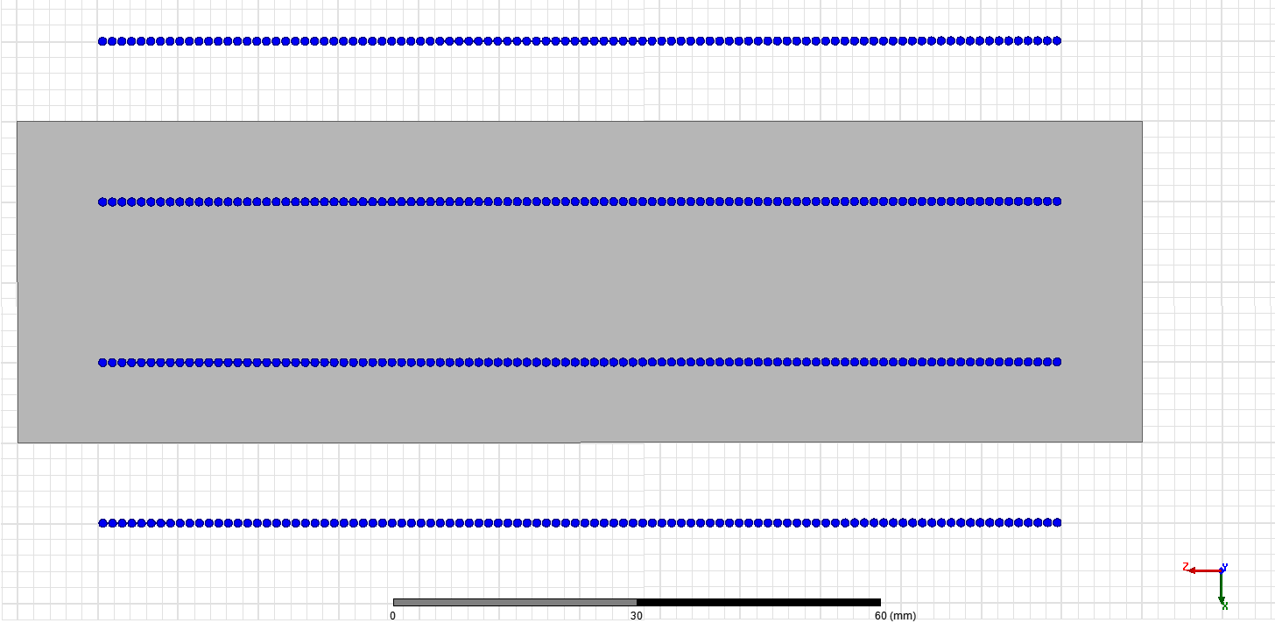
Fig. 3-2. Straight layer design
The layer area can be defined as the area of the repeating section with at least one upper and one lower side that covers the whole winding length which is shown in Fig. 3-2. as the grey area . Voltage increases step wise as the number of turns increases and the most voltage difference occurs between the first and the last turn of the winding .Unfortunately it is not possible to put the first and the last turn of the winding in the opposite ends of the layer. This results in the most voltage drop being situated with the closest proximity turns of upper and the lower part.

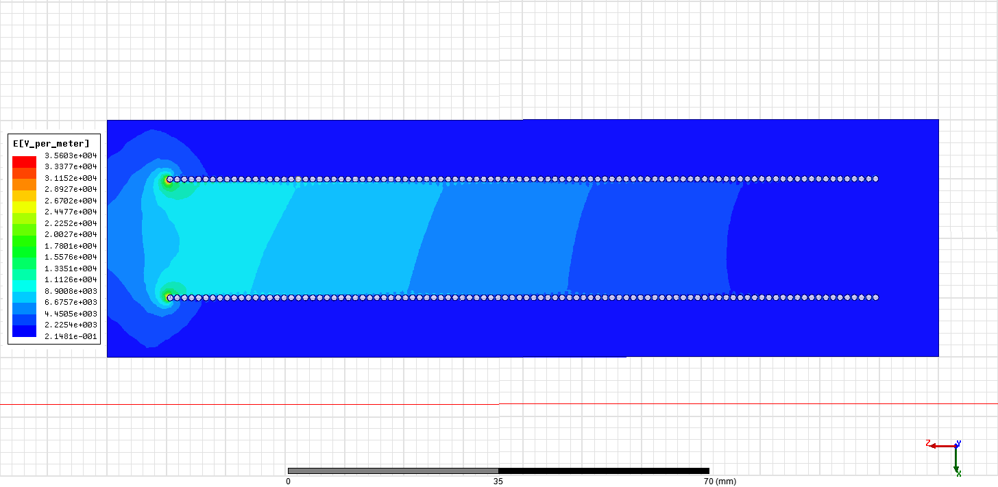
Fig. 3-3. Electric field distribution in straight layer design
It is clear from the figure Fig. 3-3. that the electric field is distributed in a highly non-uniform manner across the layer. As expected the highest electrical stress is occurred at the most outer turns of the layer with highest voltage drop in between .The electrical field at the opposite end of the layer is 10 times smaller meaning that the insulation thickness at this part is unnecessary , which makes our layer larger and costlier than it could be.
To increase the distance between the high field intensity generating points and reduce the insulation thickness at the low field end an additional step has been added to the design while keeping the layer area same (Fig. 3-4. ) . Then the analysis is repeated under the same conditions(Fig. 3-5.) .
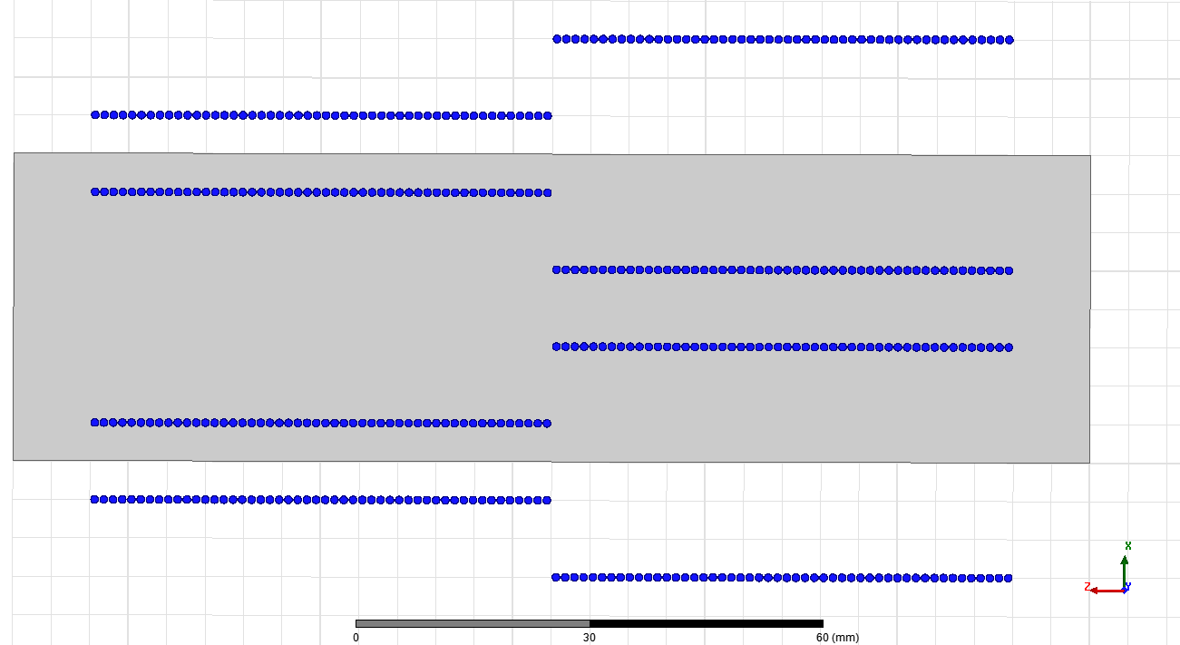
Fig. 3-4. Two step layer design
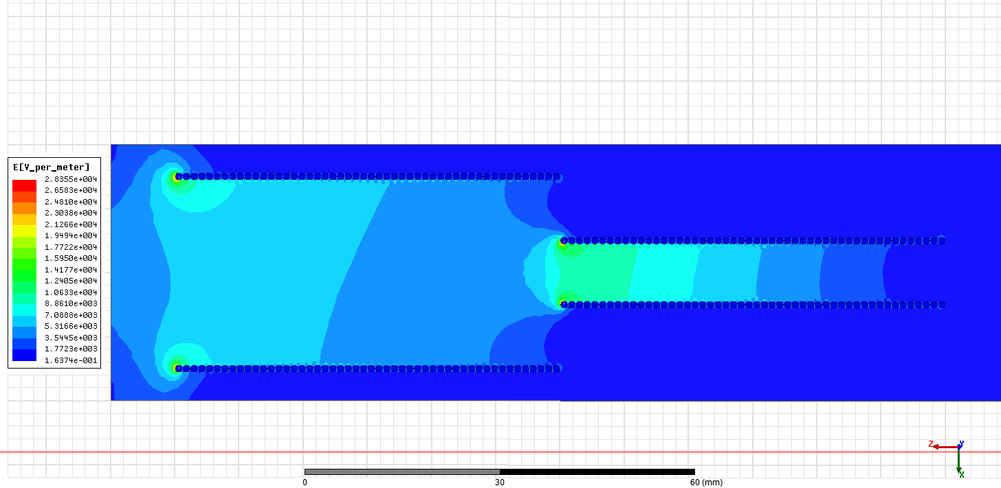
Fig. 3-5. Electric field distribution in two step layer design
When the Fig. 3-5 inspected , it is observed that adding a the step at the middle reduced the maximum field intensity from 35 kV/m to 28.35 kV/m , which is around 20 percent . The meaning of this is the layer can be fit in to a smaller area than the straight design with the same maximum field stress value , thus reducing the whole coil. Another important point is that now there are now two critical parts in the layer where the field intensified rather one.

3.2. Minimization of the Electrical Field

It is clear that adding steps helps the case of reducing the field stress but before going any further , a better understanding of the relation between the stepped design and maximum field intensity should be established. To do this ,optimization for the minimum highest electrical stress while keeping the voltage drop same and using the turn positioning as the variables will be carried out with genetic algorithm (Fig. 3-6.). GA is a robust method of solving complex problems while providing a number of potential solutions unlike the others which point out a single point in space[14]. Since our problem also involves local minimums GA is the best choice at hand.
A smaller example will be used number reduce the computational time and this is not a drawback since the only intention here is to catch a relation rather than actually doing a layer design. Due to the symmetry properties of the layer on z and x axis only 1/4 th of the turns are independent variables.
$$Cost Function=minimize Emax$$
N = 40
Wire diameter = 1mm
V_{turn} = 1 V
Area = 30mm x 70mm
Inner diameter= 200 mm
Maxwell v16.0 / Electrostatic Analysis / 2D analysis Cylindrical around Z
Total number of analysis : 3100

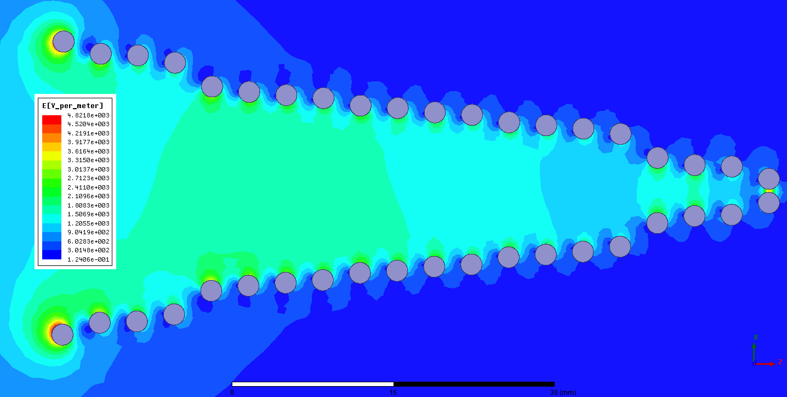
Fig. 3-6. Result of the GA optimization for 40 turns
When the resultant optimized distribution in Fig. 3-6 is inspected, it is clear that although some turns have very close positioning , none of the turns are standing at the same line. Some of the other possible solutions with close cost to the minimum the GA proposed with had some turns it the same line. So it is possible to put the turns in the middle at the same line without changing the maximum field a lot but it will reduce the uniformity of the field across the layer. The meaning of this is to have the lowest possible maximum field intensity and highest amount of uniformity , the step number must be equal to the number of turns at the same side of the layer. Making such design is impractical in mv voltage transformers because of the requirement of extremely thin insulating paper to position the high number of turns which would be impossible to find. This genetic algorithm approach where all the turns have different positioning can be used to design a layer if the number of turns are very low in the layer and insulation thickness is high enough for to construct every thickness needed to position the turns.

3.2. Reduction of the Modeling Area

The maximum field value is apparently determined by the most outer part of the layer . When the layer modeling is modified by deleting some of the inner turns which haves less impact on the field intensity while the keeping the position of the outer part turns same as the GA result , following field distribution in Fig. 3-7. is obtained .
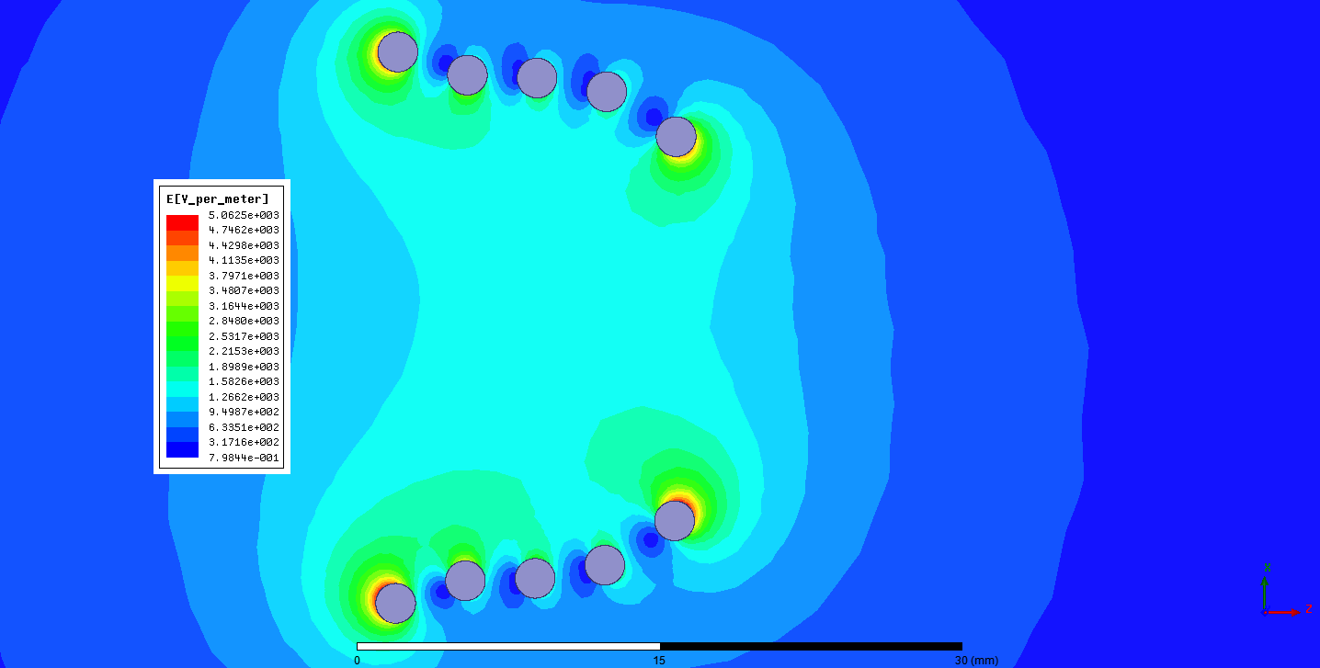 Fig. 3-7. Modified result where 30 turns removed
When the results are compared ;
E-max original: 4821 V/m - number of turns analyzed 40
E-max modified: 5062 V/m - number of turns analyzed 10
The error between the original and the modified it is calculated around 5 percent By accepting the error the number of turns analyzed are dropped by 75. If this approach of only analyzing the outer part can be applied to the common voltage transformer layer , the speed of the analysis can be increased . Also denser meshing can be applied to increase the accuracy without overwhelming the available computational power.

3.2.1 Determination of the Minimum Possible Model Area

A typical voltage transformer coil (Fig. 3-8.) layer will have over 1000 turns and thus would take a lot of time to exactly model and optimize . Also a very powerful computer is required to do the proper meshing. Therefore it is almost a must that the modeling should be simplified enough to be feasible if it is targeted to be carried out for each design.
Fig. 3-8. MV voltage transformer layer example
The layer designs are going to be used in this chapter will consist of long straight sections unlike the design proposed by GA in the figure Fig. 3-6. due to real world limitations and that could be used as an advantage. If the minimal length required to represent the whole layer with minimal error margin can be determined the finite element analysis can be executed more rapidly.
Assume a layer with following realistic properties;
N = 800
Wire diameter = 0.12 mm
V_{turn} = 1 V
L= k*a (simulated length Fig. 3-9.)
a = 0.1/0.3/0.6 ( insulation thickness)
Inner diameter= 90 mm
Simulation Properties ;
Maxwell v16.0 / Electrostatic Analysis / 2D analysis Cylindrical around Z
The whole layer will be represented starting with a small section .The behavior of the maximum electrical field will be calculated while increasing the k until we reach a point that the effect of further increasing the simulating length is negligible . Dense meshing (Fig. 3-10.) is used to decrease the effect of calculation error ,which may affect the result, as possible.
Fig. 3-9. Represented part of the whole layer
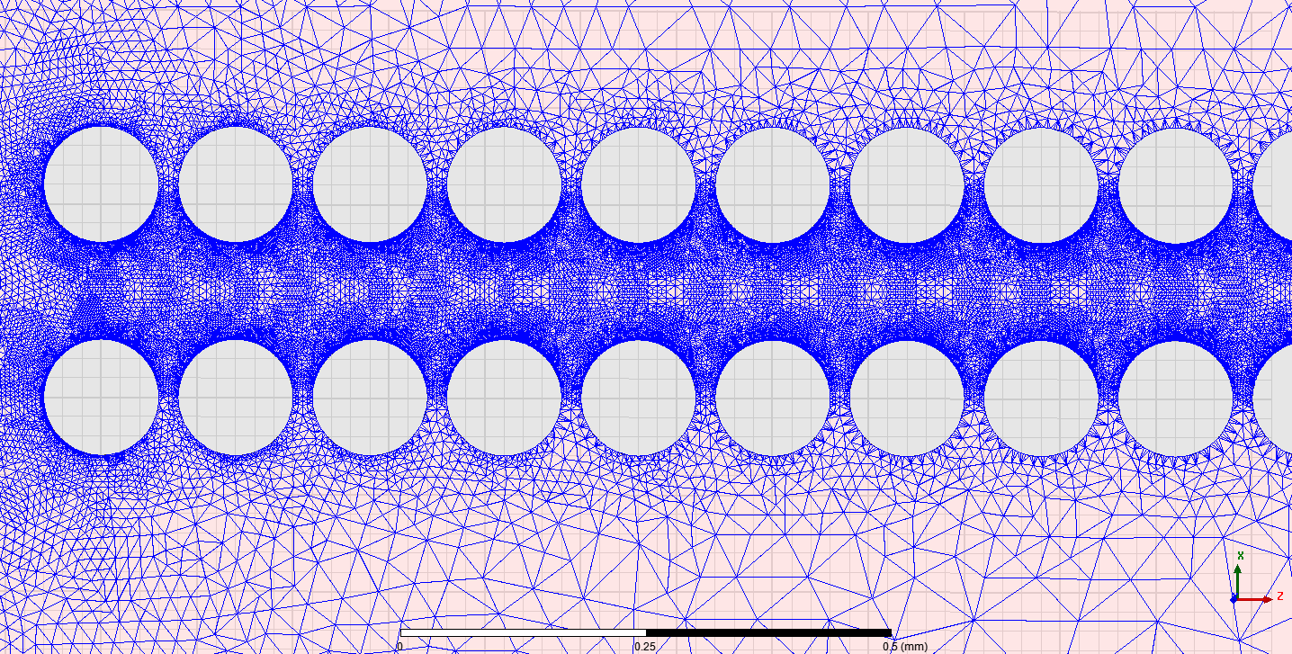
Fig. 3-10. FE analysis meshing density
To make sure that the graphs are not created with the touch of serendipity , analysis are done for three different insulation length
For a = 0.1mm , k up to 15.2 (Fig. 3-11.)
Fig. 3-11. Maximum field vs analyzed length for 0.1mm insulation thickness

For a = 0.3mm , k up to 11.6
Fig. 3-12. Maximum field vs. analyzed length for 0.3mm insulation thickness
For a = 0.6mm , k up to 5.8
Fig. 3-13. Maximum field vs. analyzed length for 0.6mm insulation thickness

When the figures are inspected it is clear that after until the k=5 mark the field value constantly increases as the k number decreases thus causing an error as also observed in Fig. 3-7. When k≥5 , the simulation error is more dominant than the effect of the omitted part as the waveform starts to oscillate randomly. By utilizing this the length that is needed to be simulated in the figure Fig. 3-8. is calculated as 5*0.42= 2.1 mm . Comparing it to the whole layer length of 106mm it is find out that only %2 percent of the turns are required to be represented to have an accurate simulation reducing the workload to simulate by a large margin.
Remarks ;
Although simulation model is greatly shrunk there are a two problem arises:
*Only the most outer region is inspected therefore it must be made sure that the maximum electrical field occurs in this part of the layer and other high stress points are safe.
*The layer should not have any step that is smaller than 5*a straight length.

3.3.Layer Template Determination

If the electric field is accepted as uniform between the two plates in space , the field intensity can be calculated as;
E=V / L
For the straight layer design in the Fig. 3-3. there is only one point of interest which is the most outer turn of the layer and the field is there can be assumed as
E_{outer} = V_{layer} / L_{outer}
and as long as that Eouter is smaller than the predetermined critical value the design will hold true.
For the 2 step design in the Fig. 3-5. there are two points of interest one is being the most outer turn and the other being the turn where the step is made.
For the most outer part again E_{outer} = Vl_{ayer} / L_{outer}
For the stepped part E_{step} = V_{step} / L_{step}
For the linear calculation of the field intensity at the step point depends on the selection of the step point and in-between insulation thickness of the stepped part. If it is made sure that
E_{step} ≤ E_{outer}
holds true also the following will also be true
E_{step(actual)} ≤ E_{outer(actual)}
since the most nonlinearity will always occur at the most outer side of the layer because of the increased distance with the same geometry will cause more nonlinearity in the field distribution.
To gain maximum amount of uniformity and guarantee a symmetrical layer layout by using this method
E_{step} = E_{outer}
will be used because this way only limit the difference of the fields at the critical points is the uniformity change of the field.
In the figure Fig. 3-5.
E_{outer}=E_{step}= 200V/30mm = 100V/15mm = 6667 V/m Linear wise
E_{out(actual)} = 34655.56 V/m Simulation Result
E_{step(actual)} = 26536.38 V/m Simulation Result
The simulation holds with the claim as E_{outer(actual)} > E_{step(actual)} while the linear fields are the same , therefore this method can be used to construct layer templates.

3.3.1 Step Types

Equality of the linear electrical field at the critical points method will be used when selecting our step points and insulation lengths . This way the highest actual electrical field value will occur at the most outer part of the layer and therefore modeling approach discussed in section 3.2.1 can be used for these templates .
For the even numbers of the insulating paper normal steps , for the odd number of the insulating paper shifted steps can be utilized to satisfy the equality condition.
n = Insulating paper thickness used ( 10 micron , 20 micron , 30 micron ..... etc)
a= Total insulation thickness of the layer
H = Height required to repeat the layer
E_{outer}= Maximum electric field value of the most outer section
k = Integer
E_{step(k)=} Maximum electric field value of the step k increasing from outside to inside
V = Relative voltage drop
Ø = Wire diameter
Normal steps:

Shifted Steps:

The number of the templates available can be increased infinitely with the usage of the same approach but it should be noted that the maximum step number thus maximum number of turns can be placed in the same height will be ultimately limited by the section length , insulating paper thickness and manufacturing time.
It is also clear that usability of the templates are dependent on the number of kraft papers in between the most outer layer. The more number of paper there is to work with the more variety of templates can be applied for the same section length so our selection space enlarges. This makes usage of thinner insulating paper when constructing the layers more advantageous compared to the thicker ones.
Drawbacks ;
This design algorithm ensures the maximum E field criteria is satisfied with minimal error margin but that does not mean that the resultant design is the most optimized . Especially when the section length gets larger it is possible to make slight adjustments to the step points of the design with the help of the finite element analysis to gain more uniformity of the field across. This slight adjustment can optionally be done after choosing the layer layout with the current process . Whole section should be modeled and step points should be adjusted with genetic algorithm . Overall the benefits will be minimal since the maximum electric field value will not change (unless steps smaller then 5*a used). Also this effort would most likely be overshadowed by the production non idealities.

3.4.Calculation of possible steps for gt30a

The layer templates that have been created in 3.3 will be adapted to gt30a. Using the method described in the chapter 3.2 a table of possible sets of layers depending on the insulation length will be calculated and tabulated by using optimization.

3.4.1. Layer Design Parameters for gt30a

With the help of finite elements method the maximum length can be winded without exceeding the critical voltage level will be calculated for each possible insulation thickness To carry out the analysis first the maximum electric field allowed and the component dimensions of the gt30a need to be determined (Table 3-1.).
Critical Electric Field Intensity;
The coil will be subjected the Sf6 gas injection at 5 bar. Since the filler in the resin is not suitable to guarantee the sealing of this pressure during the lifetime of the transformer , all calculations are going to be made as 1 bar pressure and normal operating voltage.
The corona inception voltage of the pure Sf6 gas under normal conditions is 9 kv/mm as discussed at chapter 2.1 . The design criteria will be selected When we add the same safety factor of the standard as %20 percent the design voltage is resulted around 25 kV . The maximum allowed field strength will be selected as 6.5 kV/mm to have some safety margin . Transformer is going to be subjected to a highest system voltage of 36/root3 in the three phase operation
6.5kV/mm
Wire Diameter , Insulating Paper & Layer Length;
In the standard production 30 micron kraft paper is used . The width of the core window is 180 mm and it is the limit of our length. %10 percent filling of the Sf6 gas in to that gap around the wires is assumed. The multilayer kraft paper layers will be modeled as a single layer.
Optimization;
The objective is to match the insulation thickness to the length of the layer which results in the 6.5 kV/mm critical field level by using optimization instead of trial and error to gain calculation time. There will be no local minimums so sequential nonlinear programming which gives the fastest response ,in this particular problem of the Maxwell will be used.
$$Cost Function=minimize 100*{(Emax-6500000)}^{2}$$
The optimization has only one independent variable which is the voltage of the last turn.
First and last 25 turns will be simulated and it will be checked if the 5*a rule holds (Fig. 3-14.). The thickness of the insulation will be increased 30 micron at a time until the layer length reaches 180 mm. Since the worst case will occur in the most inner layer it will be simulated. Meshing density of the analysis is given in the Fig. 3-15.
By using the number of turns allowed for each end point distances , the area and height for each type of can be calculated by using the formulas of the layer types discussed in 3.3.1.

Table 3-1. Gt30a layer parameters

Fig. 3-14. Simulated part of the layer templates

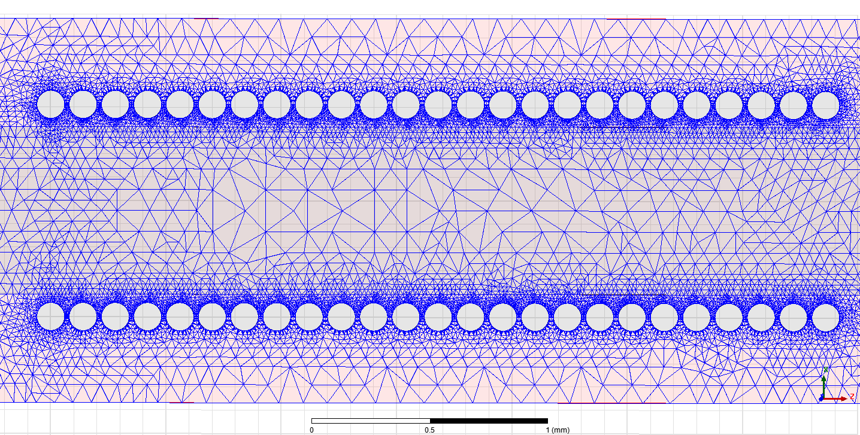
Fig. 3-15. Mesh density of the layer template simulation
Table 3-2. Gt30a possible layers

With the maximum length for the each insulation thickness is known , the applicable templates and their calculated properties are tabulated in Table 3-2 . The table should be recalculated for other applications where the electrical field intensity , wire diameter , insulating paper thickness and insulating gas may change.
Remarks;
- For the longest insulation the required simulation length is 5*a = 5* 0.69= 3,45 . For 25 turns the simulation length is 0.14*25 = 3,5 which is greater so the table is valid under an acceptable simulation error margin.
- Using a more stepped design is always resulted in smaller height for the same length.
- 3 step design is useless since it has the same height with 2-1 design and has more steps
- As the insulation goes thicker , the length of the layer does not increase linearly with it due to the field nonlinearity (Fig. 3-16.). Therefore it will start to become inefficient to increase the area by just winding longer in the same length.
Fig. 3-16. Length vs. height comparison of the simulation

3.5. Effect of stepped design on manufacturing time .

So far it looks better to have as much step as possible to have a smaller design . There is a drawback by doing it so ;
The winding machines are fast when winding the turns but slows then when the machine stops to insert the insulating paper in between .
To prove the point dependent on the machine an exemplary winding that has the same amount of turns winded with 4 different layer template. The duration of the winding process is noted for each layer type.
Number of turns : 16000
Layer length: 140 mm
wire diameter : 0.12 mm
Insulating paper : 30 micron
Winding durations* : straight : 42 min
2-1 : 52 min
three step : 63 min
2-2-2-2-1 : 72 min

*Winding duration is highly dependent on the machine used
There is a trade-off between the layer height , thus coil volume and the manufacturing time. When choosing the suitable layers from the table , the design requirements will be considered. If volume is the limiting criteria a high stepped design if not but production deadline is the limiting factor a low step design would be preferable. When doing cost calculation , high stepped design lowers material cost while low step design reduces the manufacturing cost therefore which layer to choose if all technical criteria is met is a cost optimization problem.

3.6. Irregular Layer Design

Up to now in design models templates created with between each steps we have the same number of insulating paper. While systematic layer construction is easy to apply , it actually reduces the space that we can select our layers from .
Assume we have decided to use a layer with 125 mm length in gt30a . In that case 15*30 mm kraft paper of insulation will be in our layer . According to the table available regular designs are either straight , 2-1 or 2-2-1.
if straight layer is used , height will be = 1,14 mm
if 2-1 layer is used, height will be = 0,84 mm
if 2-2-1 layer is used , height will be = 0,78 mm
and suppose even with the 2-2-1 if the desired coil volume is not satisfied , 2-2-2-2-2-2-2-1 which is not listed in the table but can be created with the same logic of shifted stepping needs to be used.
if 2-2-2-2-2-2-2-1 layer is used , height will be = 0,72 mm
A layer that is thinner than 0.72 mm is not possible with 30 micron paper for this length. If 2-2-2-2-2-2-2-1 is chosen to be employed it reduces the coil volume but increases the manufacturing time due to the huge number of stops to introduce the paper. Apparently new layer type is required which has the same total height but less manufacturing time .There is no systematic way to create such design as the normal stepped and shifted designs so the process will be trial and error.
1-3-4-4-2 irregular step design is created for 125mm section length fort the application mentioned above by trial and error.

1-3-4-4-2 does not hold the constant V/L rule so all of the high stress points must be verified to be below the critical stress . To do this modeling the whole layer would consume too much time , instead using the table for the stepping locations as if they were the most outside section to find out if the design is acceptable is a lot faster. In reality the inside stepped points have slightly lower field density than the most outside part for the same insulation length.

Inspection of the high stress points;
outer insulation 450mm winding length 125 mm allowed length 128.24 holds,
step1 insulation 420mm winding length 116.07mm allowed length 121.15 holds,
step2 insulation 360mm winding length 107.14 allowed length 107.69 holds,
step3 insulation 300mm winding length 89.28 allowed length 93.24 holds,
step4 insulation 240mm winding length 71.42 allowed length 77.09 holds,
step5 insulation 180mm winding length 53.57 allowed length 60.79 holds,
step6 insulation 120mm winding length 35.71 allowed length 43.36 holds,
step7 insulation 60mm winding length 115,38 allowed length 23,95 holds,
step8 insulation 30mm winding length 105.77 allowed length 13,04 holds,
Shortest step length is 8,92 mm and it is greater than the 5*0.45mm which is the minimum step length which makes modeling valid. None of the steps are longer than the calculated maximum lengths in the table so the design is safe to use. Worse allowed winding length vs. the winding length occurs at step 2 and limits this design for maximum application for 125.65 mm.
Although there is no certain method in creating the irregular design the rule of thumbs are;
* Always adjust the layer boundary one paper thick to get the smallest possible layer height.
* The middle section of the layer is safer so the gain will come from this part by going longer without making a step.
*Always check if the symmetry is conserved for the repeating layers

3.4.5 Chapter Summary

In this chapter a generalized approach to the layer design and modeling for the mv voltage transformer layers constructed. It has been found out that doing more steps increases the design performance-wise but cost manufacturing time and limited by the available resources. Simulating for a smaller section while keeping it longer than the minimum required distance for the given length of the layer is enough if linear voltage calculation is same for the all critical points of the layer . If linear voltage template layers do not satisfy the needs , irregular layer templates can be constructed by trial and error with the help of the pervious simulation data.
Layer Design Algorithm;
1) Determine the electrical and physical parameters for the coil.
2) Simulate the layer for possible simulation lengths with finite element analysis. Construct the available layers by using templates . Check for if the minimum simulation length constraint holds.
3) Select the layers suitable to your design layer length , decide on the tradeoff between complexity and the cost.
4) If no template layer satisfies the design requirements , create trial and error irregular layers via the table.

COIL LAYER POSITIONING & MODELING of MV VOLTAGE TRANSFORMERS

CH4 Layer Positioning
-Introduction
-3D analysis
-2D adept,
-2D model construction length voltage relation , finding initial starting point
-Choosing window length (checking resin strenght)
-Minimize E field
-grouping the layers
-Cost function
-gt30a example,
ch4-ch5 interacts with each other
CH5
Final design
production photos
Comparison
Conclusion

Bibleography:
[1] S. A. Boggs and U. Systems, “Partial Dischar e: Overview and ignal Generation 8,” vol. 6, no. 4, 1990.
[2] H. Search, C. Journals, A. Contact, M. Iopscience, and I. P. Address, “Stochastic modelling of electrical treeing: fractal and statistical characteristics,” vol. 1536.
[3] S. Boggs, “Fundamentals of Partial,” vol. 16, no. 5, 2000.
[4] M. Leijon, M. Dahlgren, L. Ming, and A. Jaksts, “A Recent Development in the Electrical Insulation Systems of,” pp. 10–15.
[5] W. Larson and A. Yezer, “The energy implications of city size and density,” J. Urban Econ., vol. 90, pp. 35–49, 2015.
[6] S. Okabe, N. Hayakawa, H. Murase, H. Hama, and H. Okubo, “Common insulating properties in insulating materials,” IEEE Trans. Dielectr. Electr. Insul., vol. 13, no. 2, pp. 327–335, 2006.
[7] G. C. Stevens and A. M. Emsley, “Review of chemical indicators of degradation of cellulosic electrical paper insulation in oil-filled transformers,” IEE Proc. - Sci. Meas. Technol., vol. 141, no. 5, pp. 324–334, 1994.
[8] U. Ststes, Gases. .
[9] E. Onal and G. Komurgoz, “CALCULATION of CORONA INCEPTION VOLTAGES in N 2 +SF 6 MIXTURES via GENETIC ALGORITHM,” no. 34469.
[10] H. Jo, G. Wang, S. Kim, and G. Kil, “Comparison of Partial Discharge Characteristics in SF 6 Gas Under AC and DC,” vol. 16, no. 6, pp. 323–327, 2015.
[11] L. G. Christophorou, J. K. Olthoff, and R. J. Van Brunt, “Sulfur hexafluoride and the electric power industry,” IEEE Electr. Insul. Mag., vol. 13, no. 5, pp. 20–24, 1997.
[12] M. Bagheri, B. T. Phung, and M. S. Naderi, “Impulse Voltage Distribution and Frequency Response of Intershield Windings,” pp. 32–40, 2016.
[13] P. Apparatus, H. T. Windings, and R. Van Nuys, “Sept/Oct 1978 INTERLEAVED,” no. 5, pp. 1946–1954, 1978.
[14] “Michalewicz Z. Genetic Algorithms + Data Structures = Evolution Programs (3ed).PDF.” .

Abrravations:

